Address Verification

🏠 What is Address Verification?
# Source: AI Source: Provided by: [Data Path: Persons Table -> ID Column: 1, Name_En Column: Motasem Essam] -> From: [Chatgpt (GPT‑5 Mini)] on [1/20/2026]
Address verification is the process of confirming that a person’s physical or mailing address is real, valid, and actually associated with them. It's used to prevent fraud, ensure deliveries, and meet compliance standards.

📦 Why Address Verification Is Used
# Source: AI Source: Provided by: [Data Path: Persons Table -> ID Column: 1, Name_En Column: Motasem Essam] -> From: [Chatgpt (GPT‑5 Mini)] on [1/20/2026]
✅ To:
- Ensure accurate product delivery
- Prevent fraudulent orders
- Comply with KYC (Know Your Customer) and AML (Anti-Money Laundering) regulations
- Match a person to their residential or billing address

🛠️ How Address Verification Works
# Source: AI Source: Provided by: [Data Path: Persons Table -> ID Column: 1, Name_En Column: Motasem Essam] -> From: [Chatgpt (GPT‑5 Mini)] on [1/20/2026]
There are two main types:
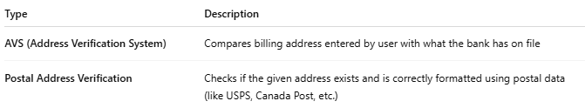
Type | Description
AVS (Address Verification System) | Compares billing address entered by user with what the bank has on file
Postal Address Verification | Checks if the given address exists and is correctly formatted using postal data (like USPS, Canada Post, etc.)

🧪 Methods of Verifying an Address
# Source: AI Source: Provided by: [Data Path: Persons Table -> ID Column: 1, Name_En Column: Motasem Essam] -> From: [Chatgpt (GPT‑5 Mini)] on [1/20/2026]
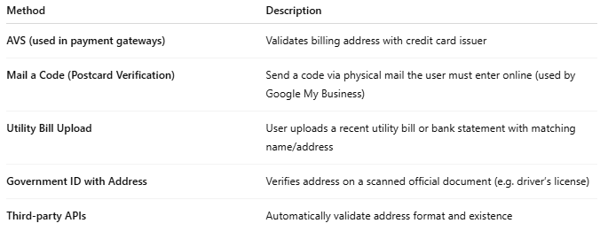

Method | Description
AVS (used in payment gateways) | Validates billing address with credit card issuer
Mail a Code (Postcard Verification) | Send a code via physical mail the user must enter online (used by Google My Business)
Utility Bill Upload | User uploads a recent utility bill or bank statement with matching name/address
Government ID with Address | Verifies address on a scanned official document (e.g. driver’s license)
Third-party APIs | Automatically validate address format and existence

🌐 Address Verification APIs / Services
# Source: AI Source: Provided by: [Data Path: Persons Table -> ID Column: 1, Name_En Column: Motasem Essam] -> From: [Chatgpt (GPT‑5 Mini)] on [1/20/2026]
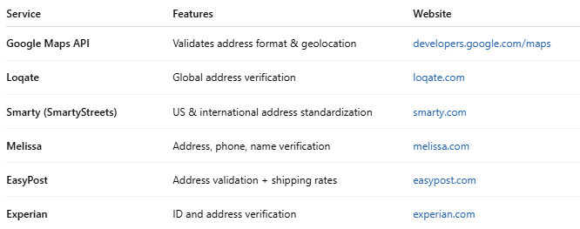

Service | Features | Website
Google Maps API | Validates address format & geolocation | developers.google.com/maps
Loqate | Global address verification | loqate.com
Smarty (SmartyStreets) | US & international address standardization | smarty.com
Melissa | Address, phone, name verification | melissa.com
EasyPost | Address validation + shipping rates | easypost.com
Experian | ID and address verification | experian.com

✅ Example Use Case
# Source: AI Source: Provided by: [Data Path: Persons Table -> ID Column: 1, Name_En Column: Motasem Essam] -> From: [Chatgpt (GPT‑5 Mini)] on [1/20/2026]
- 🧍 User enters a shipping address when buying online
- 📡 System uses an API to validate the address format and existence
- ✅ If valid → proceed with order
- ❌ If invalid → prompt user to correct the address

